BANNARI AMMAN INSTITUTE OF TECHNOLOGY
(An Autonomous Institution Affiliated Anna University, Chennai)
Sathyamangalam – 638401



TECHNOVA HACKATHON 2026

PROJECT DOCUMENTATION

ON

NetGuard - Automated Network Change Management
and Rollback System

Developed By
Team localhost

TEAM MEMBERS:

Register Number Name
7376241CS289 Nandhakumar A
7376242AD235 Niranjan J

Phase 1 Documentation – Problem Analysis & Tool Design

1. Introduction

1.1 Purpose
NetGuard is a network automation system that simplifies configuration management by automating backups, validation, deployment, rollback, monitoring, and reporting.

1.2 Scope
The system provides:
- Device Discovery
- Configuration Backup
- Configuration Validation
- Change Deployment
- Automatic Rollback
- Network Monitoring
- Report Generation

2. Problem Statement
Manual network configuration is time-consuming and prone to errors, which may lead to downtime and security issues. NetGuard automates configuration changes with validation, backup, and rollback to improve reliability.

3. Objectives
- Automate configuration management
- Reduce configuration errors
- Validate changes before deployment
- Create automatic backups
- Support rollback recovery
- Monitor device status
- Generate reports

4. System Requirements

Functional Requirements
- User Authentication
- Device Management
- Network Discovery
- Configuration Backup
- Configuration Validation
- Configuration Deployment
- Automatic Rollback
- Dashboard Monitoring
- Report Generation

Non-Functional Requirements
- Secure role-based access
- Reliable backup process
- Fast system response
- Scalable for multiple devices
- Modular and maintainable design

5. Target Users
- Network Administrator
- Network Engineer
- Security Team
- IT Manager

6. System Workflow
User Login
│
▼
Device Discovery
│
▼
Configuration Backup
│
▼
Configuration Validation
│
▼
Deploy Configuration
│
┌───┴────┐
│ │
Success Failure
│ │
▼ ▼
Dashboard Rollback
│
▼
Generate Reports

7. System Architecture
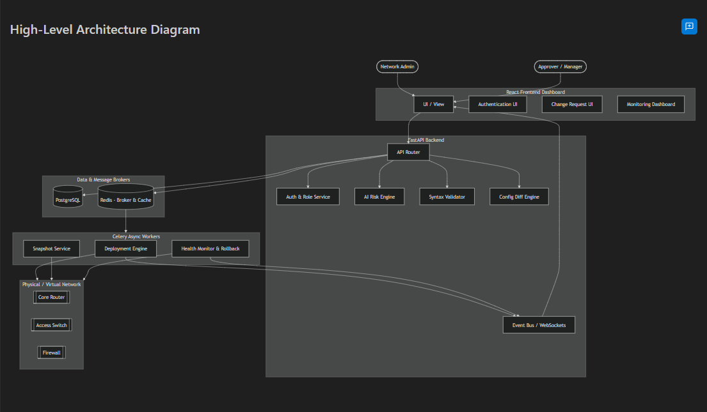
Components
- Dashboard – User Interface
- Flask API – Application Logic
- Policy Engine – Security Validation
- Config Engine – Backup & Deployment
- Netmiko – Device Communication

8. Technology Stack

🎨 Frontend (UI & Client-Side)
- React – Core library for building the user interface.
- TypeScript – Provides static typing for improved code quality and maintainability.
- Tailwind CSS – Used for responsive and modern UI styling.
- Vite – Fast development server and build tool.
- Recharts – Used for dashboards, analytics, and data visualization.

⚙️ Backend (API & Business Logic)
- Python 3.11+ – Primary programming language.
- FastAPI – High-performance backend framework for REST APIs.
- SQLAlchemy – ORM for database operations.
- Celery – Handles asynchronous background tasks such as deployments and snapshots.
- Alembic – Database schema migration tool.

🤖 Artificial Intelligence
- Llama LLM – Used for intelligent analysis of network configuration changes, risk assessment, and AI-assisted recommendations before deployment.

💾 Database & Cache
- PostgreSQL – Stores users, devices, configurations, audit logs, and change requests.
- Redis – Message broker for Celery and caching layer for improved performance.

🔌 Network Automation
- Netmiko – Secure SSH-based network device automation.
- NAPALM – Multi-vendor network configuration management.
- Paramiko – SSH connectivity and secure communication with network devices.

🐳 Infrastructure & Deployment
- Docker – Containerization platform for application deployment.
- Docker Compose – Orchestrates frontend, backend, database, and Redis services using a single configuration.

9. Protocols & APIs
Protocol | Purpose
SSH | Secure Device Communication
REST API | Application Communication
TCP/IP | Network Connectivity
10. System Modules
- Authentication – Login and role-based access.
- Device Management – Add, update, delete, and view devices.
- Network Discovery – Discover devices and monitor connectivity.
- Configuration Backup – Store running and startup configurations.
- Configuration Validation – Check syntax, VLANs, interfaces, and IP conflicts.
- Policy Engine – Verify security compliance.
- Change Management – Compare and track configuration changes.
- Rollback Management – Restore backup after deployment failure.
- Dashboard – Display status, alerts, and recent activities.
- Report Generation – Generate backup, compliance, and activity reports.
11. Phase 1 Deliverables
- Problem Analysis ✔
- Requirement Analysis ✔
- Workflow Design ✔
- Architecture Design ✔
- Module Design ✔
- Technology Selection ✔

12. Conclusion
Phase 1 establishes the foundation of NetGuard by defining the system requirements, workflow, architecture, modules, and technologies. The solution ensures secure and reliable network configuration management through automation, validation, backup, and rollback.

Core Tool Development

Phase 2 – Core Tool Development

Objective
During this phase, the core modules of NetGuard were developed using a FastAPI backend and a web-based frontend. The application provides a secure interface for managing network devices, submitting configuration changes, and monitoring deployments.

Implemented Features
- User Login and Registration
- Dashboard
- Device Management
- Change Request Module
- Deployment Tracking
- Audit Logs
- Role-Based Access Control

Screenshot Placement
Figure 2.1 – User Registration and Login Interface
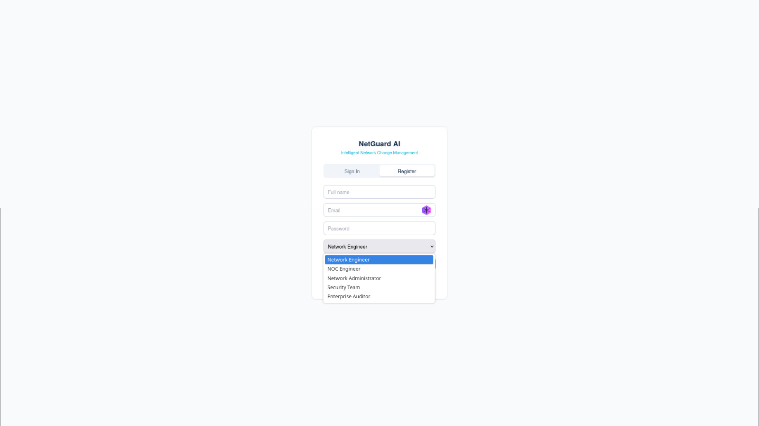

Figure 2.1 User authentication interface supporting secure registration and login with role selection.

Backend & Network Connectivity

Network Connectivity
The backend was developed to support secure communication with network devices using SSH-based connections. Libraries such as Netmiko, Paramiko, and NAPALM were included for device connectivity.

Backend Modules
- Device Model
- User Authentication
- API Services
- Database Models
- JWT Authentication

Screenshot Placement
Figure 2.2 – Backend Device Model
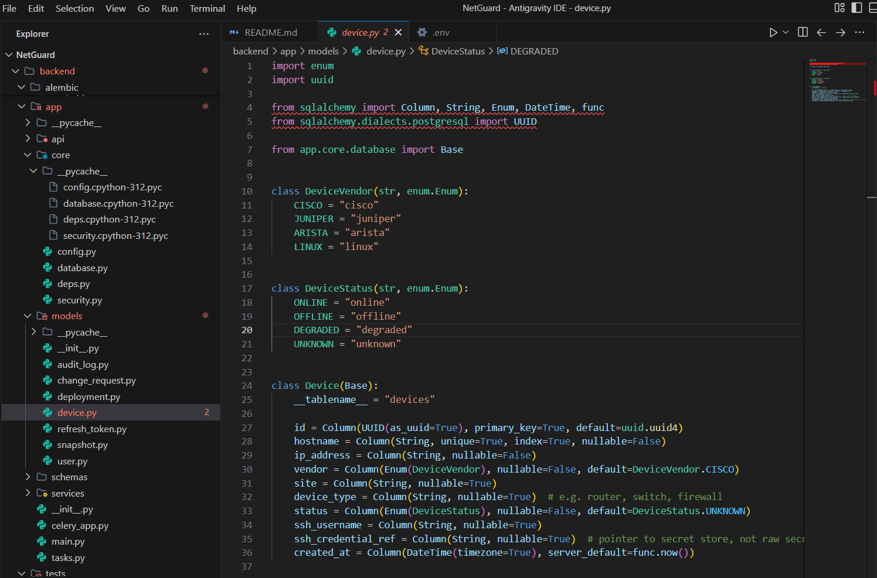
Figure 2.2 Device model implementation defining network device properties and operational status.

Figure 2.3 – Authentication Dependency

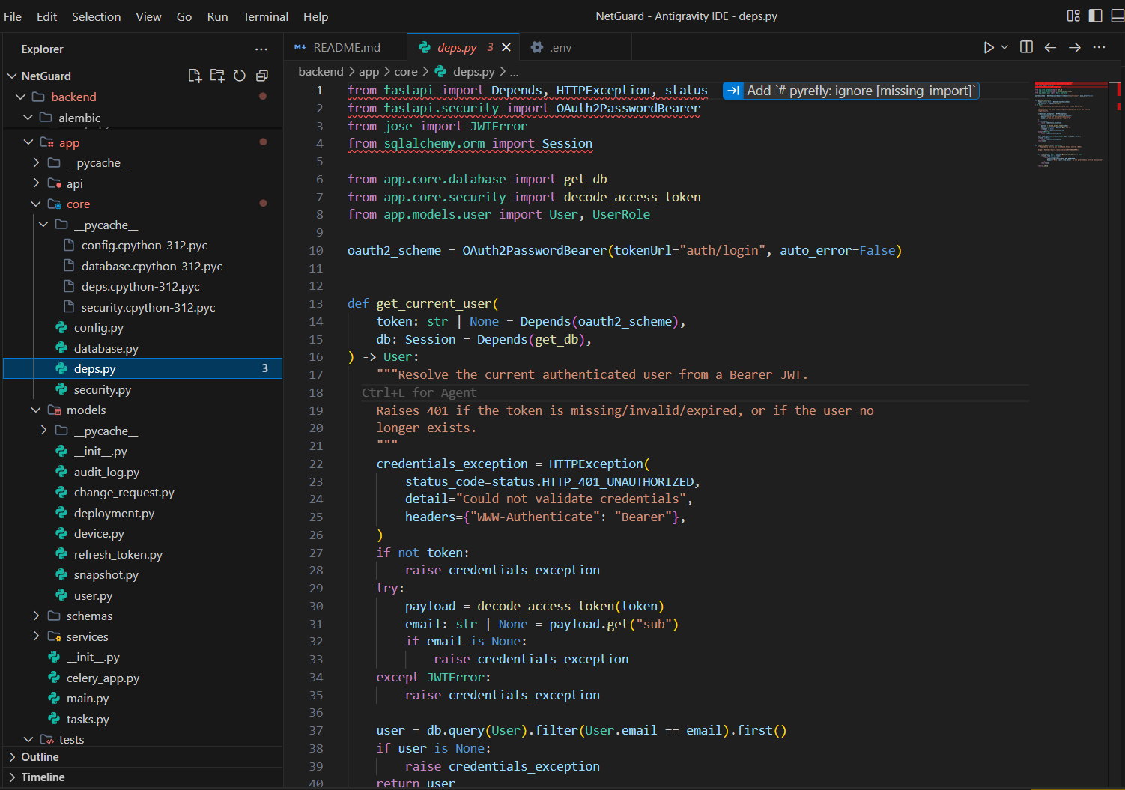
Figure 2.3 Authentication dependency validating JWT tokens and authenticated users.

Figure 2.4 – Backend Requirements
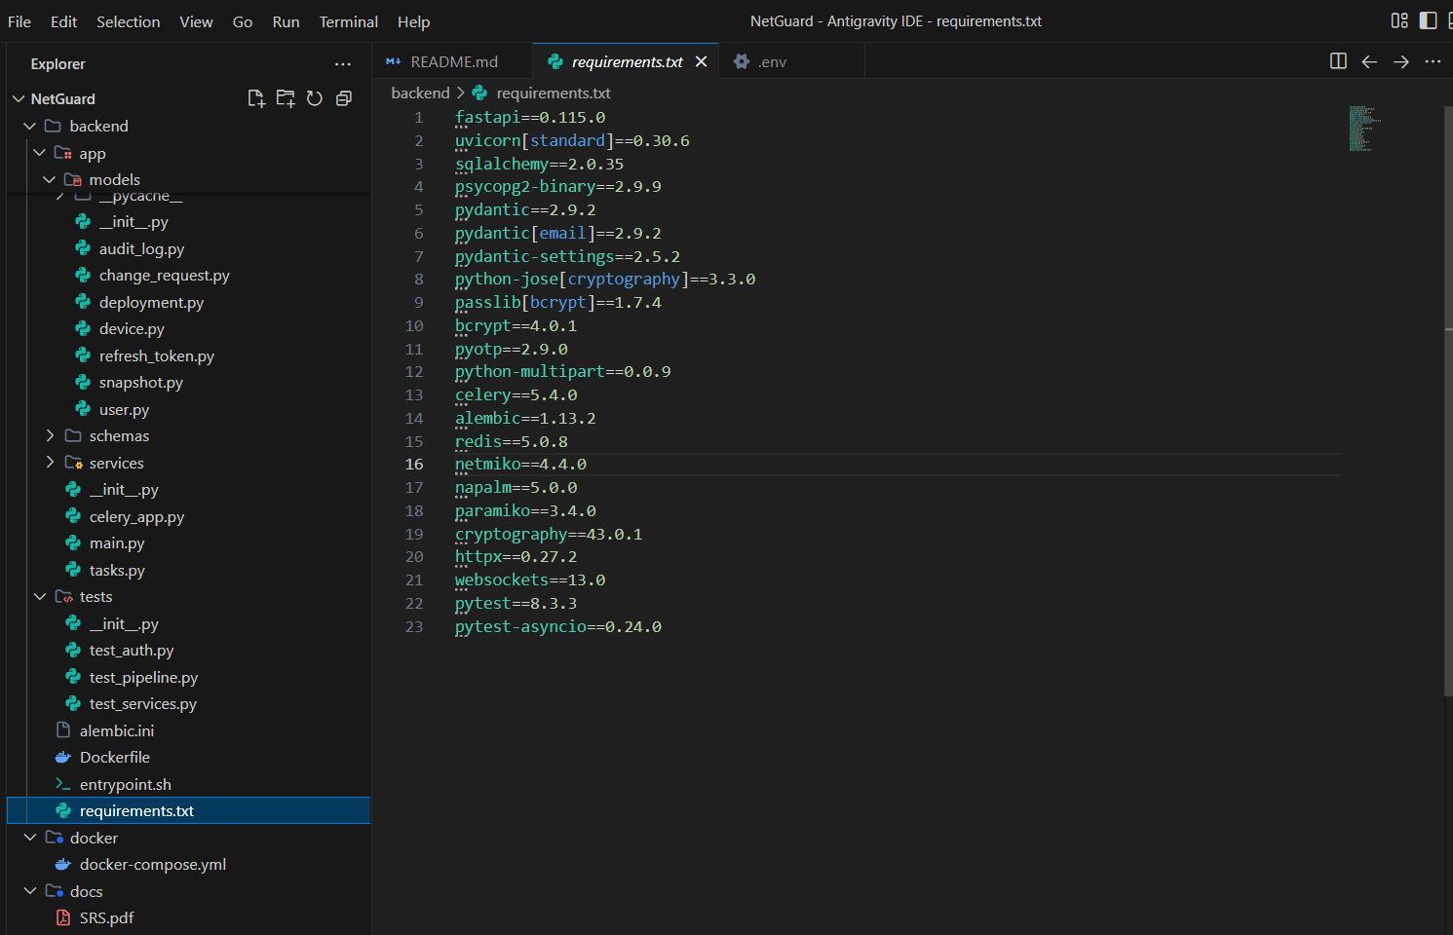
Figure 2.4 Python libraries used for backend services and network communication.

Dashboard & Monitoring

Dashboard
The dashboard provides a quick overview of the network environment and deployment status.

Dashboard Features
- Devices Online
- Active Deployments
- Pending Approvals
- Failed Deployments
- Rollbacks
- Platform Status

Screenshot

Figure 2.5– Dashboard
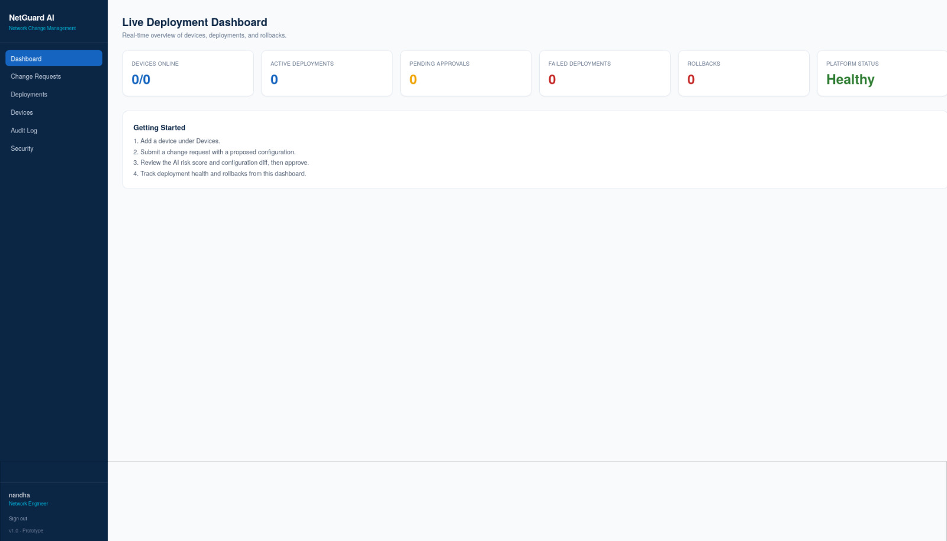

Configuration Analysis & Policy Validation

Configuration Parsing and Analysis
The NetGuard AI system allows users to submit network configuration changes before deployment. Every submitted configuration undergoes validation and preliminary analysis.
The system performs the following operations:
- Configuration parsing
- Change validation
- Risk assessment preparation
- Configuration storage
- Approval workflow initialization
The architecture has been designed so that advanced AI-based compliance checking and policy validation can be integrated in future versions.

Policy Validation
Each submitted configuration is verified against predefined operational rules to ensure consistency and minimize deployment risks.
Validation includes:
- Device selection verification
- Configuration completeness
- Request tracking
- Deployment approval workflow
- Change history recording

Screenshot Placement
Figure 2.6 – Change Request Module
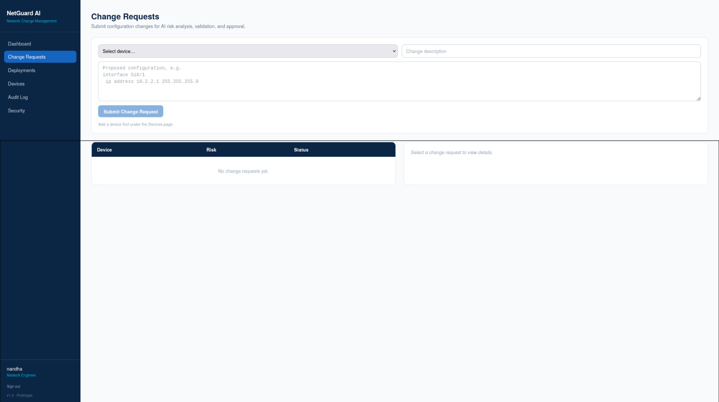

Security, Reporting & Phase Summary

Security and Reporting
Security was implemented as a major component of the application. The platform includes authentication, role-based authorization, and Multi-Factor Authentication (MFA) for enhanced protection.
The application supports:
- JWT Authentication
- Password Encryption
- Two-Factor Authentication
- Secure Session Management
- Audit Logging
- Role-Based Access Control
All important user actions are recorded within the audit logging module, improving accountability and traceability.

Reporting and Alerts
The dashboard provides summarized operational reports including deployment counts, approval status, rollback information, and platform health indicators. These reports assist administrators in monitoring the network efficiently.

Screenshot Placement
Figure 2.7 – Security Module
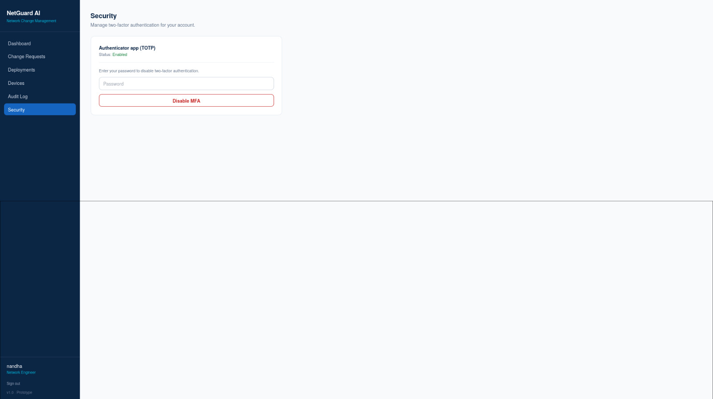
Figure 2.7 Multi-Factor Authentication (MFA) management interface for enhancing account security.

Phase 2 Outcome
The Phase 2 implementation successfully established the core architecture of the NetGuard AI platform. The developed modules provide secure user authentication, backend APIs, network device integration readiness, configuration management, dashboard visualization, monitoring, policy validation, and reporting capabilities. These components form the foundation for advanced AI-driven network automation and intelligent deployment features planned for subsequent phases.

Phase 3 – Integration, Validation & Optimization

3.1 Integrate All Modules into a Complete Working Tool

Objective
To integrate all application modules into a unified network management platform.

Description
The frontend and backend modules were successfully integrated to provide a centralized dashboard for managing network devices. Device Inventory and Network Topology modules were connected, allowing administrators to monitor devices, view topology, and access device details from a single interface.

Screenshot Placement : Figure 3.1 – Device Inventory Page

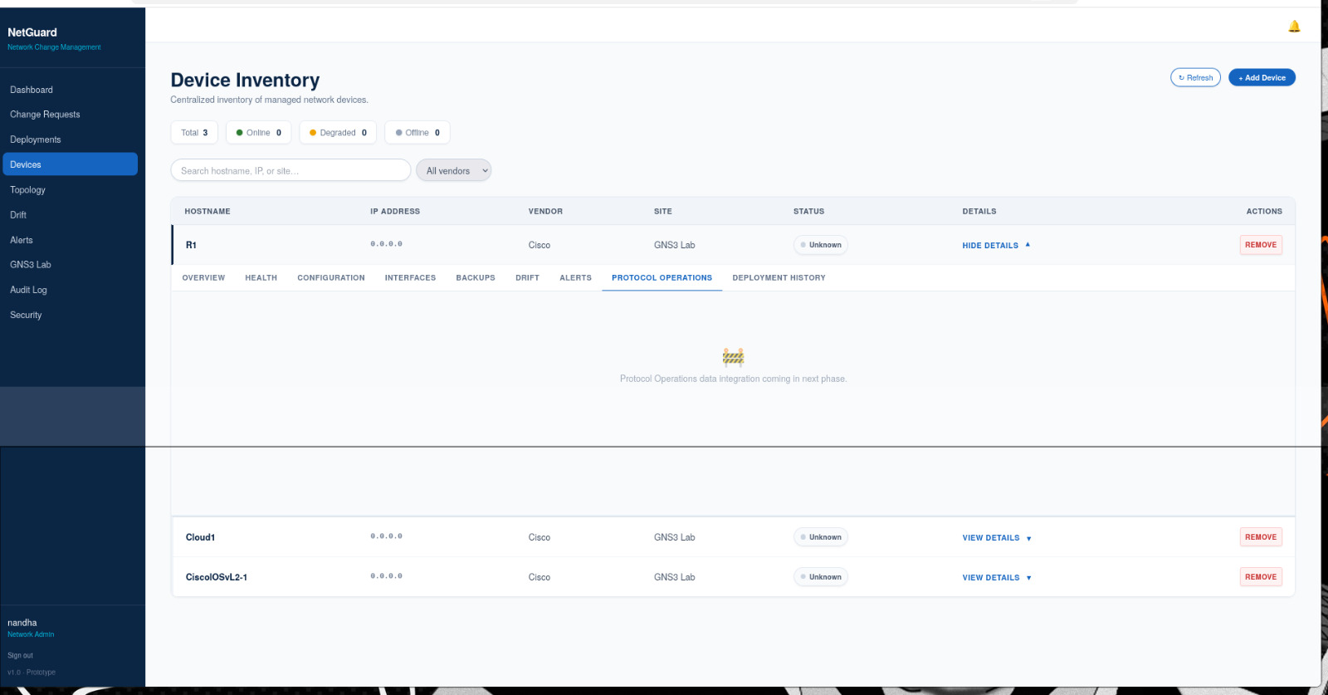
Figure 3.1: Device Inventory module displaying the list of managed network devices along with their status, configuration details, protocol operations, and deployment history.

Figure 3.2 – Network Topology Page

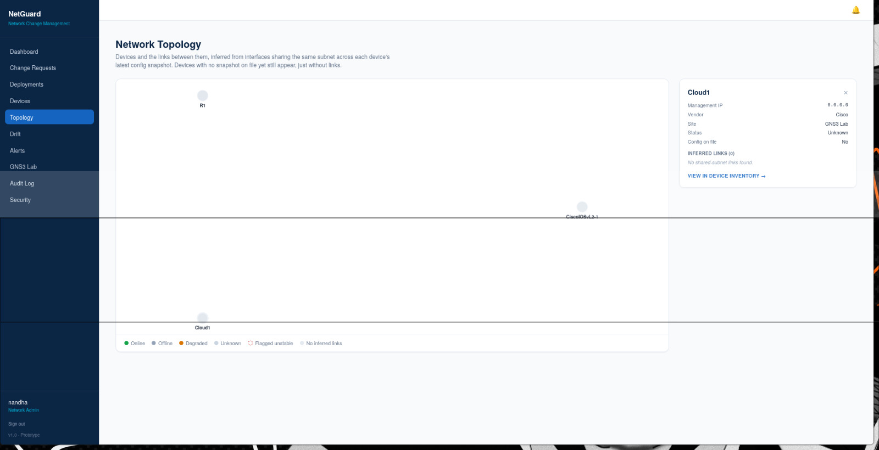

Figure 3.2: Network Topology view showing the connected network devices and their relationships, providing a graphical representation of the network infrastructure.

3.2 Validate Outputs Against Network Policies and Problem Requirements

Objective
To validate network configurations and ensure compliance with project requirements.

Description
Configuration Drift analysis was implemented to compare device configurations with the baseline configuration. Compliance scores and drift status help identify configuration changes and ensure devices remain consistent with network policies.

Figure 3.3 – Configuration Drift Page
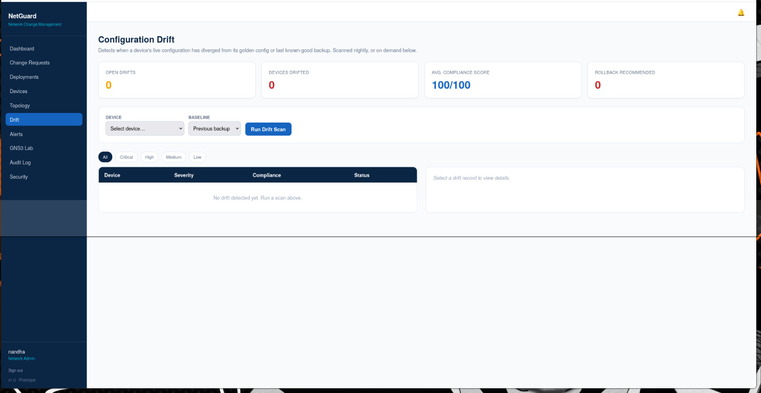

Figure 3.3: Configuration Drift module used to compare the current device configuration with the baseline configuration and identify any configuration deviations.

3.3 Test Network Scenarios, Protocol Behavior and Automation Workflow

Objective
To verify the functionality of the network automation workflow.

Description
The application was tested using a GNS3 virtual network environment. Multiple network devices were connected and configured to validate communication, protocol operations, and overall automation workflow.

Figure 3.4 – GNS3 Network Topology
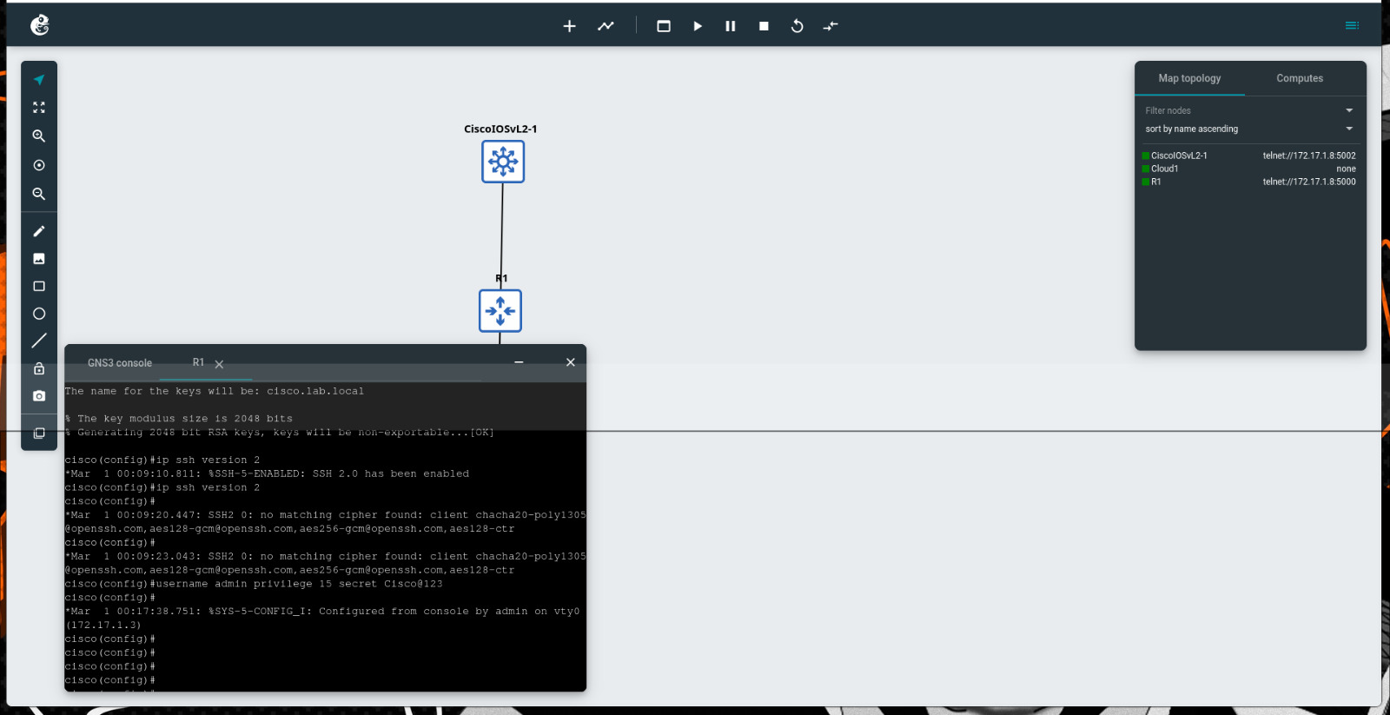
Figure 3.4: GNS3 virtual network environment used for testing device connectivity, protocol configuration, and validating the network automation workflow.

3.4 Implement Logging, Error Handling and Report Generation

Objective
To improve system monitoring and maintain complete activity records.

Description
An Audit Trail module was implemented to record user activities, deployment events, and system operations. The logs provide complete traceability and help monitor successful and failed operations performed within the platform.
Figure 3.5: Audit Trail
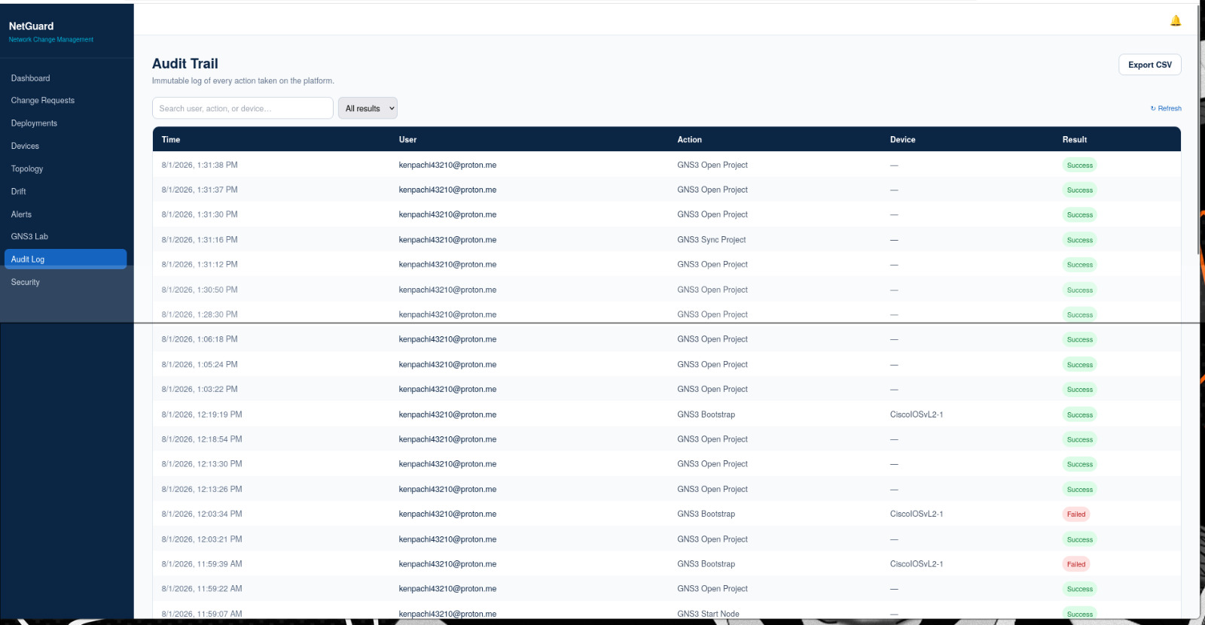

Figure 3.5: Audit Trail page recording user activities, deployment events, and system actions to ensure complete monitoring and traceability.

3.5 Optimize Tool Performance, Scalability and Usability

Objective
To enhance the overall usability and performance of the application.

Description
The dashboard was optimized to provide a responsive user experience with real-time network statistics, deployment status, device health information, alerts, and backup summaries. The interface enables administrators to quickly monitor the overall network environment.
Figure 3.6: Network Dashboard
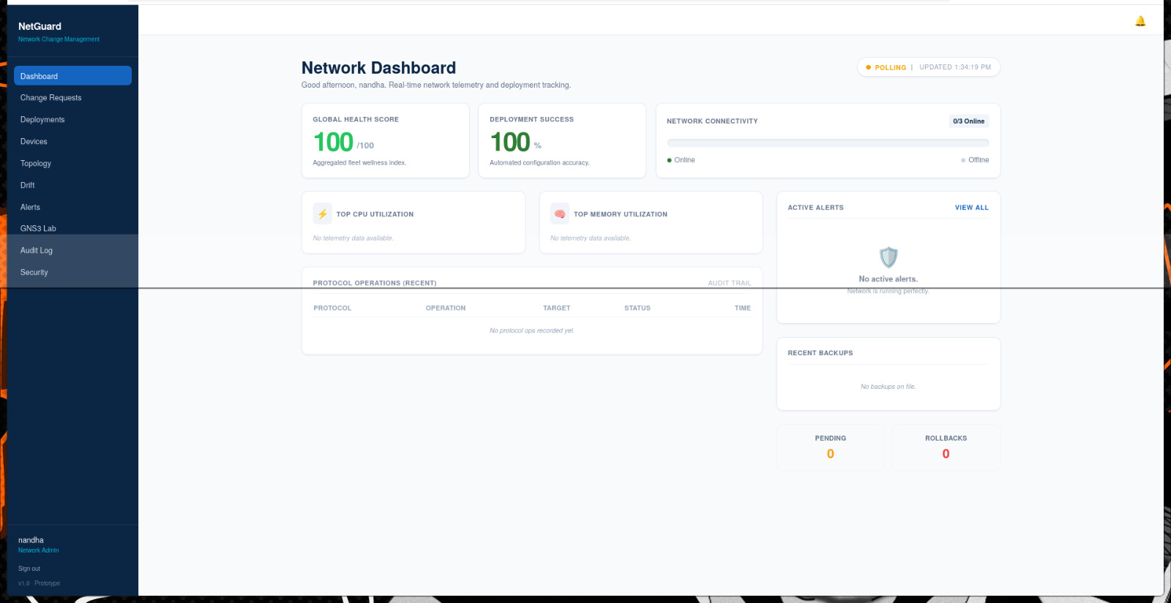
Figure 3.6: Network Dashboard presenting overall network health, deployment statistics, alerts, connectivity status, and recent operational information.

Phase 3 Outcome
Phase 3 successfully integrated all modules into a unified platform, validated key functionalities, and optimized system performance. The tool was tested in the GNS3 environment, ensuring reliable network monitoring, configuration management, and overall usability.

Phase 4 – Deployment & Final Demonstration

4.1 Deploy the Complete Application

Objective
To deploy the integrated network change management system and ensure all modules function together successfully.

Description
The complete application was deployed using Docker and Docker Compose, integrating the React frontend, FastAPI backend, PostgreSQL database, Redis cache, and Celery task queue. Network automation modules, including Netmiko, NAPALM, and Paramiko, were configured to communicate with network devices. The deployment process verified seamless communication between all system components and ensured that the application was stable, responsive, and ready for real-time operation.

4.2 Final System Demonstration & Validation

Objective
To demonstrate the complete workflow and validate the overall functionality of the application.

Description
The complete network change management workflow was demonstrated by creating change requests, performing AI-based risk analysis using the Llama Large Language Model (LLM), validating network configurations, and deploying configuration changes to network devices. The deployment process was monitored through the dashboard, while audit logs and configuration history verified successful execution. The final demonstration confirmed that the system provides reliable network automation, intelligent risk assessment, centralized monitoring, and efficient change management.

Phase 4 Outcome
The application was successfully deployed and demonstrated as a complete network change management solution. All core modules worked together effectively, providing AI-assisted risk analysis, automated configuration management, monitoring, and audit logging. The final system was validated and confirmed to be stable, efficient, and ready for practical use.

THANK YOU

Thank you for your time and valuable feedback.

